**Branching in Git**

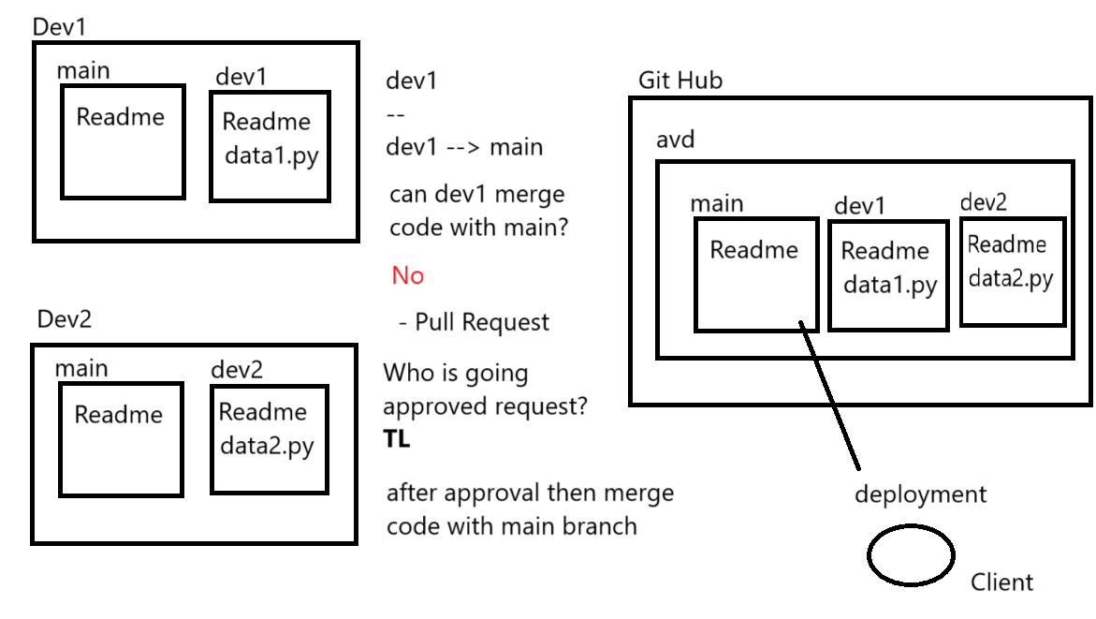

* Branch is a copy of main branch at certain stage which will be used to develop certain features.
* We can create separate branches for different functionalities and later merge them with the main branch.
* To see the list of local branches

git branch

* To create a branch

git branch branch_name

* To move into a branch

git checkout branch_name

* To create a branch and also move into it

git checkout -b branch_name

* Push branch to remote repo

git push - -set-upstream origin new_branch_name

* To delete a local branch that is merged

git branch -d branch_name

* To delete branch from remote repo

git push origin --delete dev1

**Git Merge**

* Merge keeps all commit history and creates merge commits.

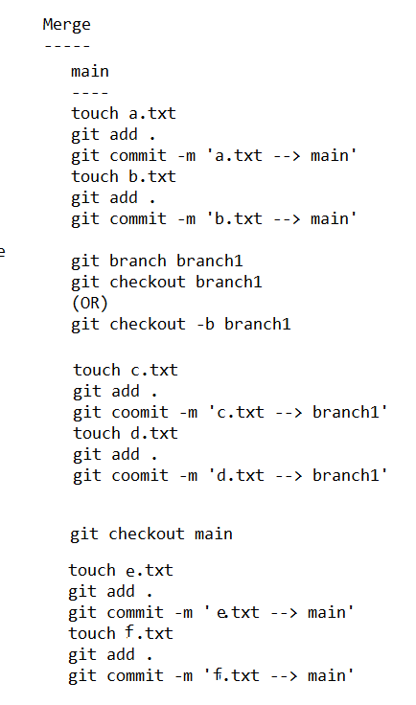

git merge branch1

**Git Merge with Squash**

* Squash Merge simplifies commit history into a single commit.



* git merge –squash branch1

Git has staged the changes from the branch we are merging (branch1), but it hasn't created a commit yet.

* git status
* git commit -m "commit message"

**Git rebase**

* This is called as fast forward merge where the commits coming from a branch are projected as the top most commits on master branch



* git checkout branch1
* git rebase main
* git checkout main
* git merge branch1